|  |
| --- |
| UNIVERSITY of hertfordshire |
| Kaspar3 User Manual |
| First Draft |
|  |
| **Adaptive Systems Research Group** |
| **11/5/2014** |

|  |
| --- |
|  |

Contents

Technical Terminology 1

Starting Kaspar 1

Admin Section 2

Actions 4

Group Action 5

Pose Action 5

Sequence Action 7

Sound Action 7

Action Import 8

# Technical Terminology

* *Operator*: Adult User of the system. (Researcher, Teacher, Parent)
* *User*: Child User of the System
* *Action*: Things Kaspar can do (Poses, Groups, Sequence, Sounds)
* *Trigger*: Things that cause Actions (Button Press, Sensor Press, Timed)
* *Play Session*: Interaction with a User consisting of one or more Play Scenarios
* *Play Scenario*: A combination of Actions and Triggers built to advance specific objectives
* *Researcher UI*: Interface primarily concerned with modifying the Actions available, best used with a mouse
* *Teacher UI*: Interface for use during an Play Session, designed for use on a tablet

# Starting Kaspar

The power button is located on the back of Kaspar, just below the waist. Depress the button to turn on the power. Kaspar can run both with or without the charger connected.

Boot time on Kaspar is approximately 45seconds, and it will run a short ‘wake-up’ sequence when it has finished booting.

To begin working with the KASPAR3, connect your device of choice to the WIFI access point kaspar3_X where X is the Kaspar number. Next open a Web browser and navigate to 192.168.3.1. The interfaces have been extensively tested in Chrome, but should be functional in all HTML5 compatible browsers.

You should now see the screen shown below:

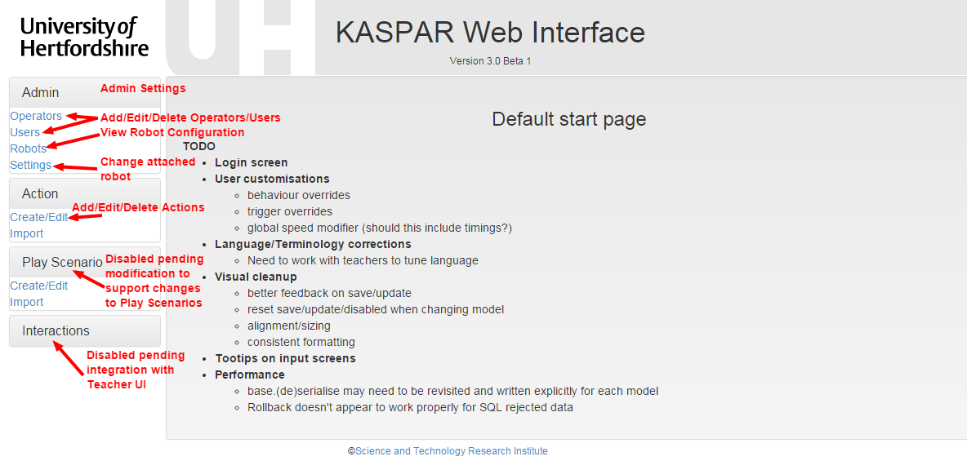

# Admin Utilities

There is currently very little that can be modified in the Admin Section of the menu. You can add/edit operators, view the current Robot configuration and select the Robot that is currently connected. This last setting should be used with caution, as it will change the calibration data that is loaded.

The following images explain the various admin screens.

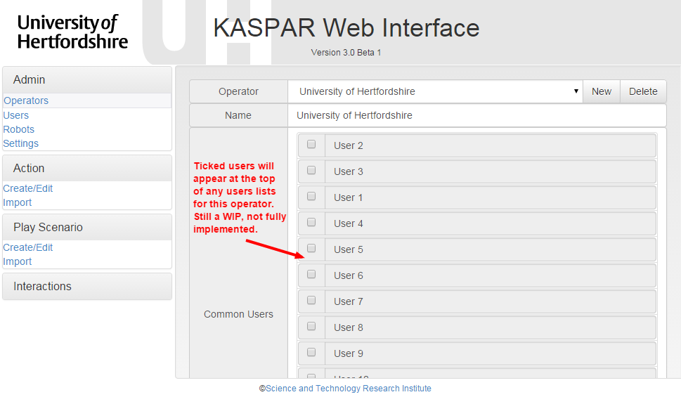

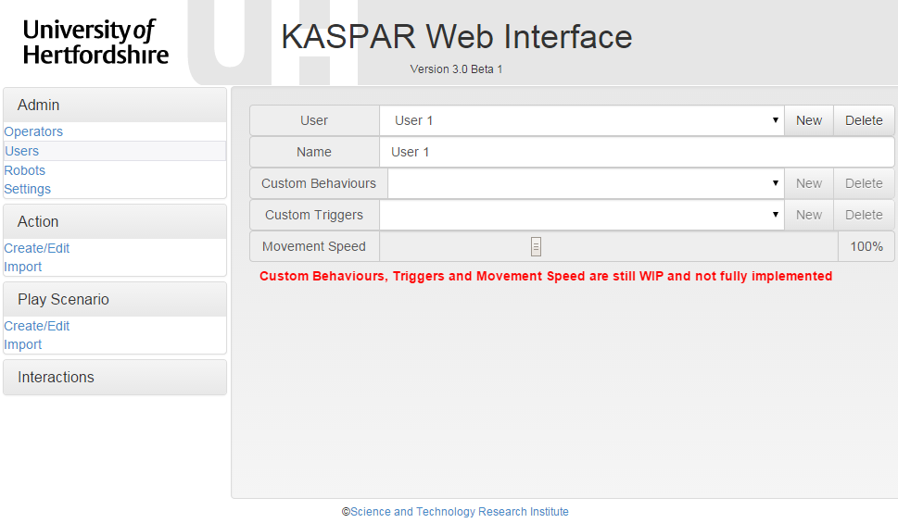

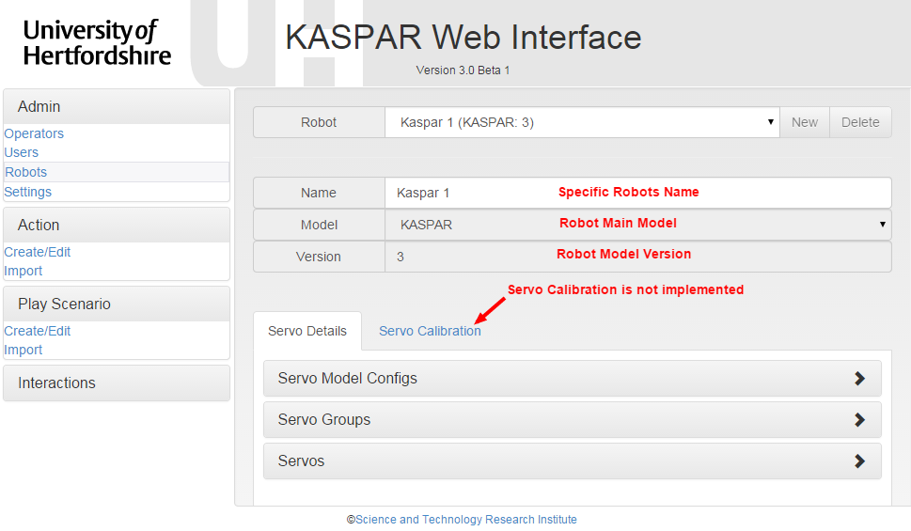

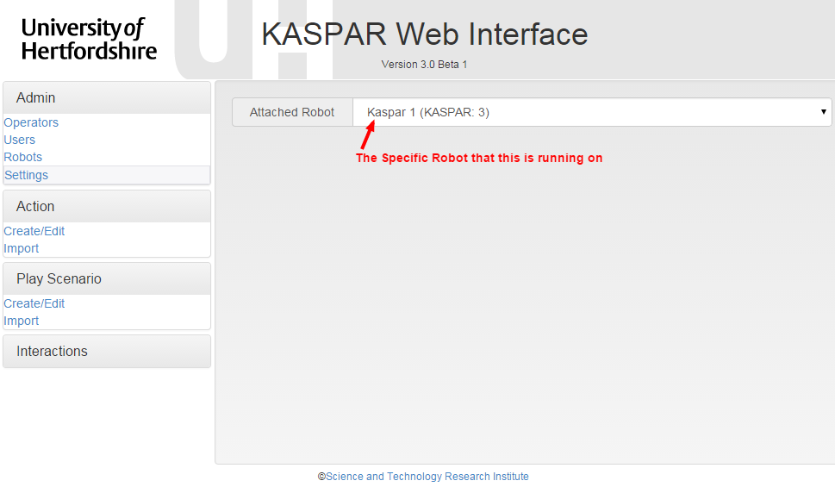

# Actions

The Actions section is where any changes to stored actions, including adding and deleting of actions occurs.

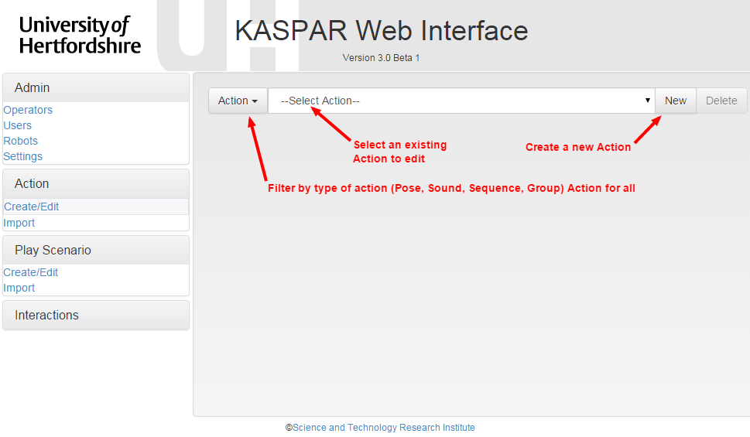

There are several common features of all of the Action Editors, they are indicated below.

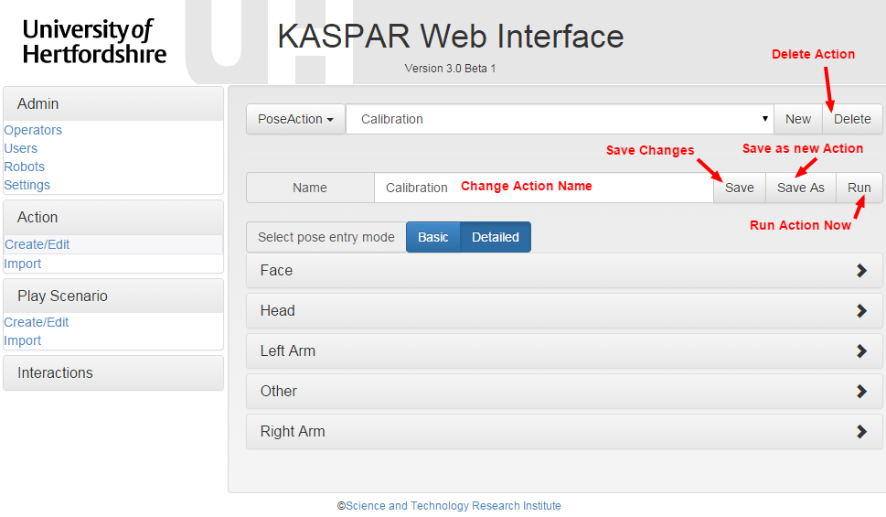

## Group Action

The Group Action type collects multiple Actions and allows them to run in parallel. This can be useful for playing a Sound at the same time as Movement is occurring.

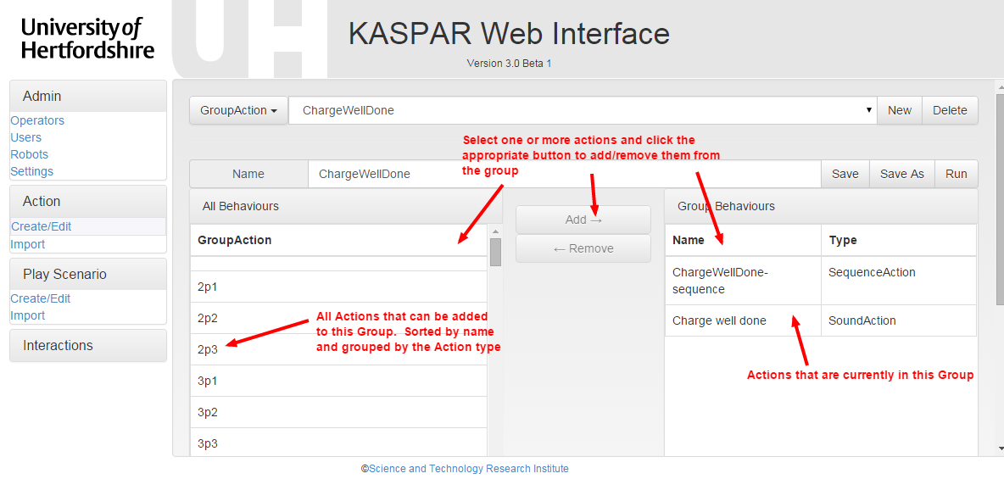

## Pose Action

Poses are a collection of one or more Joint Positions and can be thought of as the basic Action of Kaspar. In addition to the position, a speed can be set for each Joint, changing how quickly it will attempt to reach the desired position. The speed is a modifier applied to the baseline speed for that servo, as indicated in the servo model configuration.

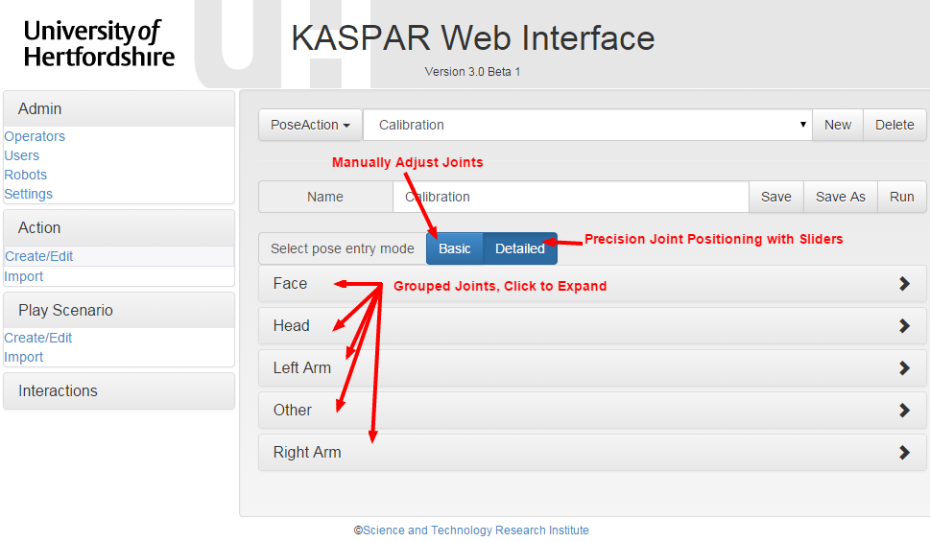

The Pose editor has two operational mode, Basic and Detailed. In Basic mode, the servos are set by releasing one or more servos, and manually moving them into position before locking them again. The editor will record the position that they are in when locked.

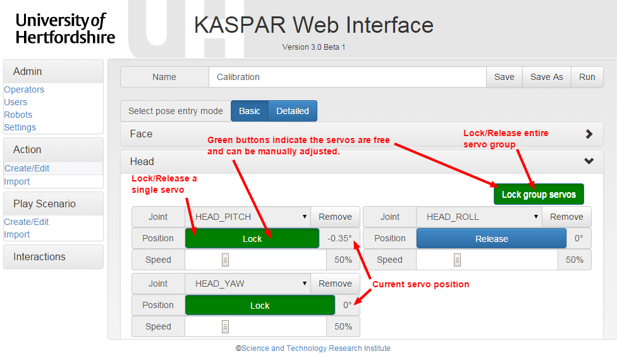

Detailed mode allows for more precise control of the servos, and must be used for the face servos, as they do not support manual positioning.

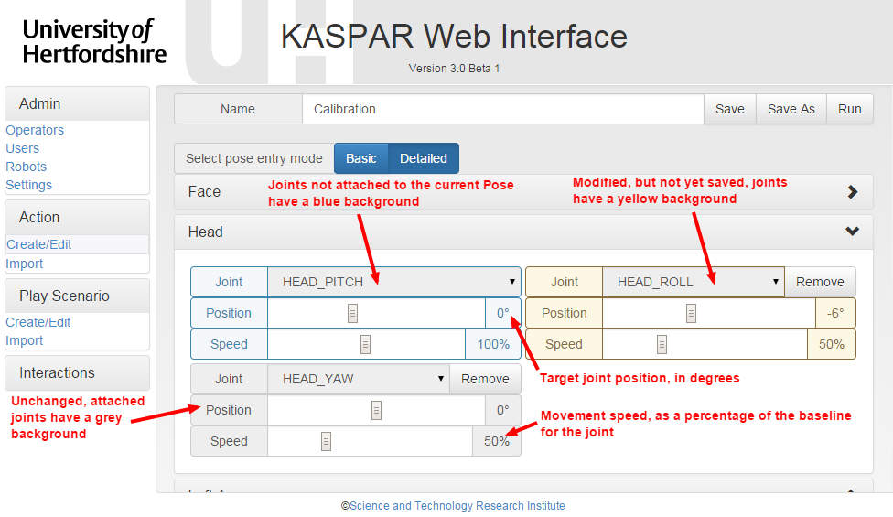

## Sequence Action

Sequences are groups of Actions that are run in a specific order. Additionally, they have an optional property that specified the total run time of each step of the sequence. This is the time from the start of that step, to the start of the next step. If a step in a sequence does not complete in the given time, it will be stopped so that the sequence can continue on time. Similarly, if a step finished before the specified time, a pause will be inserted for the remaining step time. This timing can be useful for timing movements to certain points in a Sound.

If this Run Time value is not specified, the next step will begin as soon as the previous step finished.

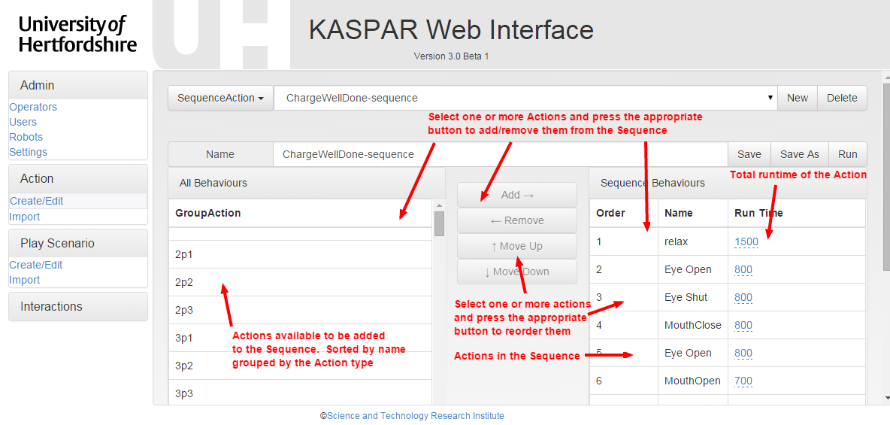

## Sound Action

Sound Actions are wav files that Kaspar can play. Each Sound can have the volume adjusted independently, which can be used to compensate for sound files that are too loud or too quiet.

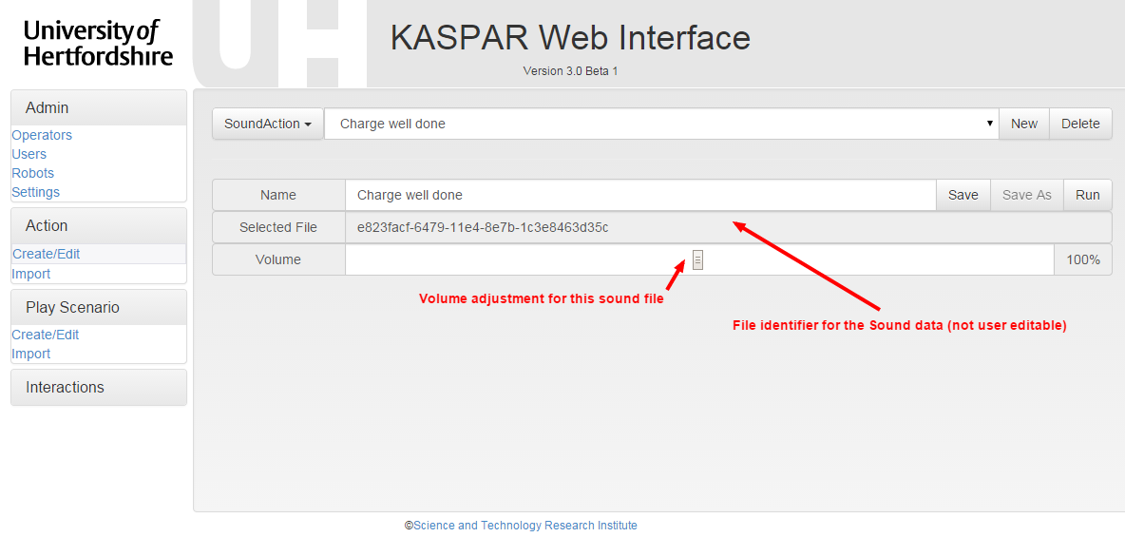

To add a new sound, first select a wav file and click upload. Finish by giving it an identifiable name and clicking save.

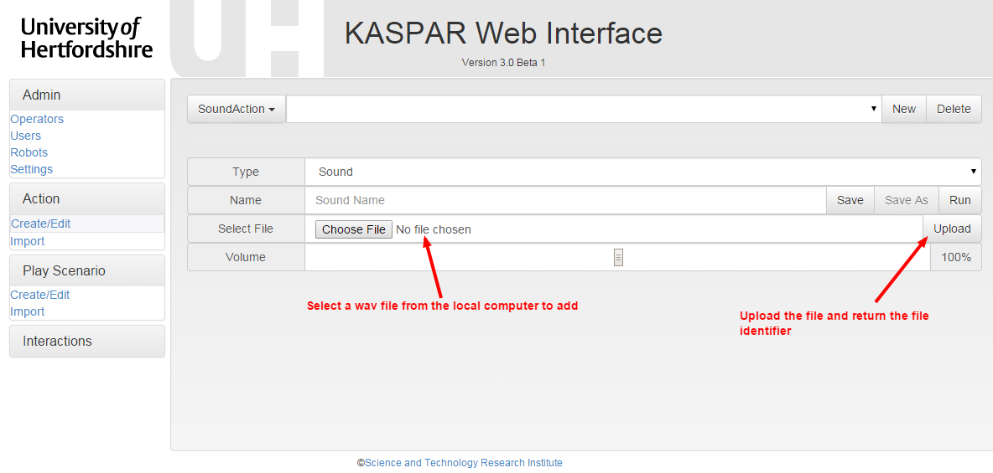

## Action Import

The final method of entering actions is to import a Kaspar1 formatted .seq or .pos file. Kaspar3 will attempt to convert these to the current format, with varying degrees of success.

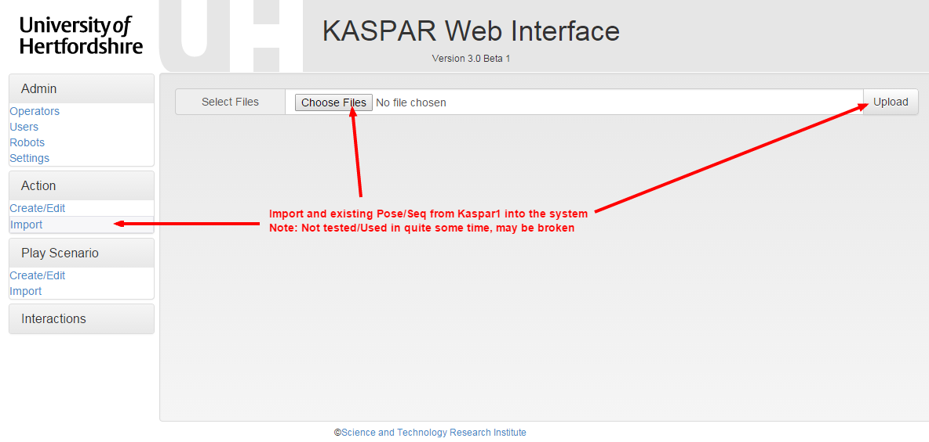

# Play Scenarios

Due to changes in the structure of Play Scenarios, this section has been temporarily disabled.

# Interactions

This section will offer an embedded Teacher UI for researchers to use for testing purposes; it has not yet been implemented.